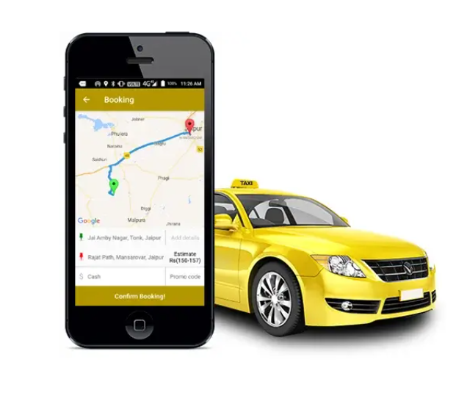
Online cab booking process
Travel Bot

Step 1: Open PAI@HR in Teams.
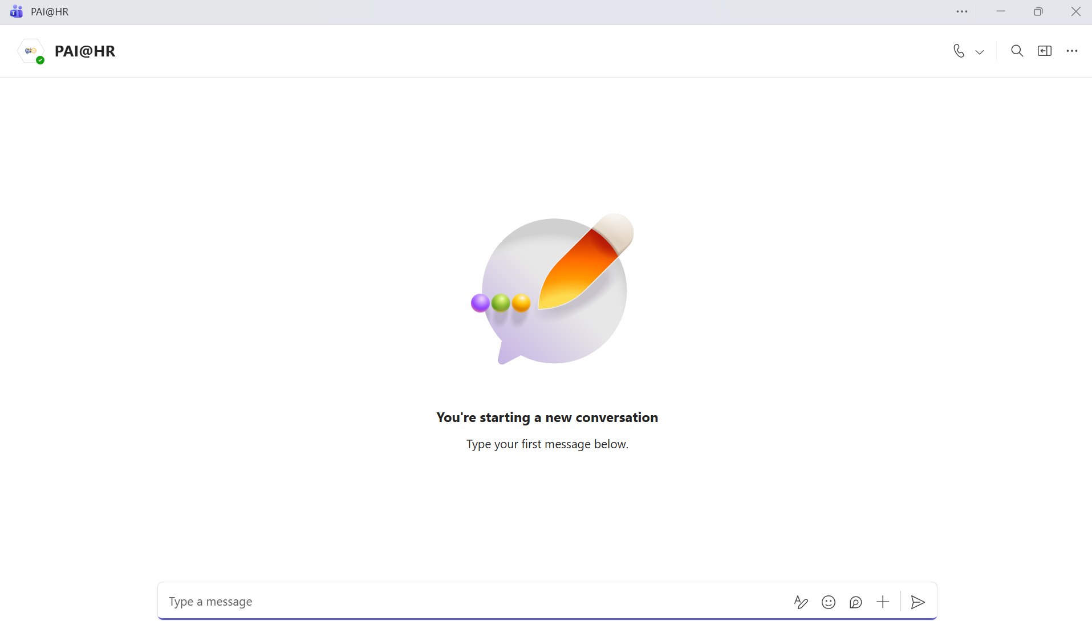
Step 2: You can type: “Cab Booking” for making a cab booking request.
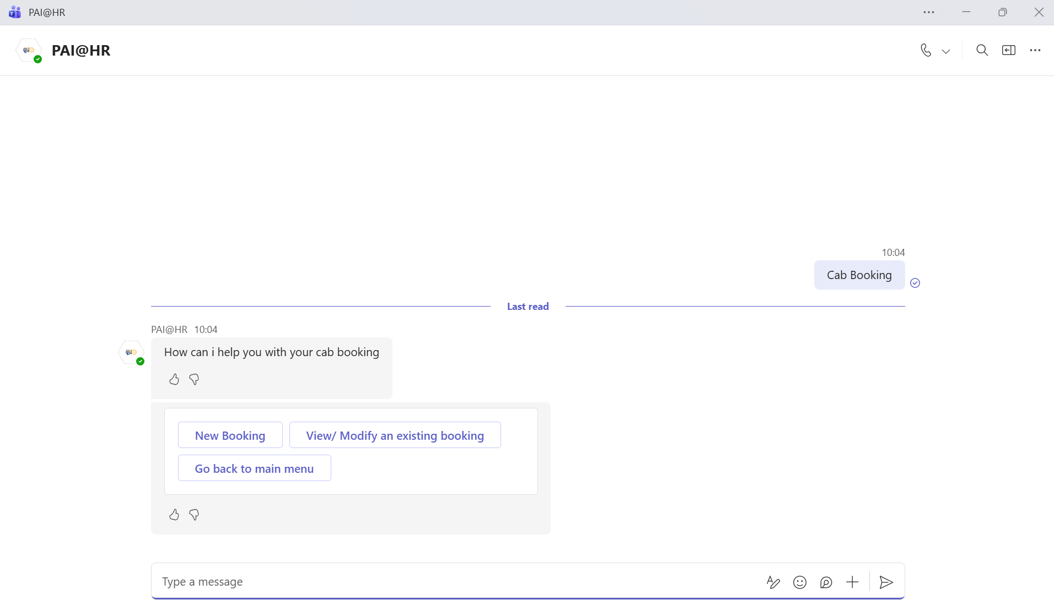
Step 3: Go to New Booking to proceed ahead.
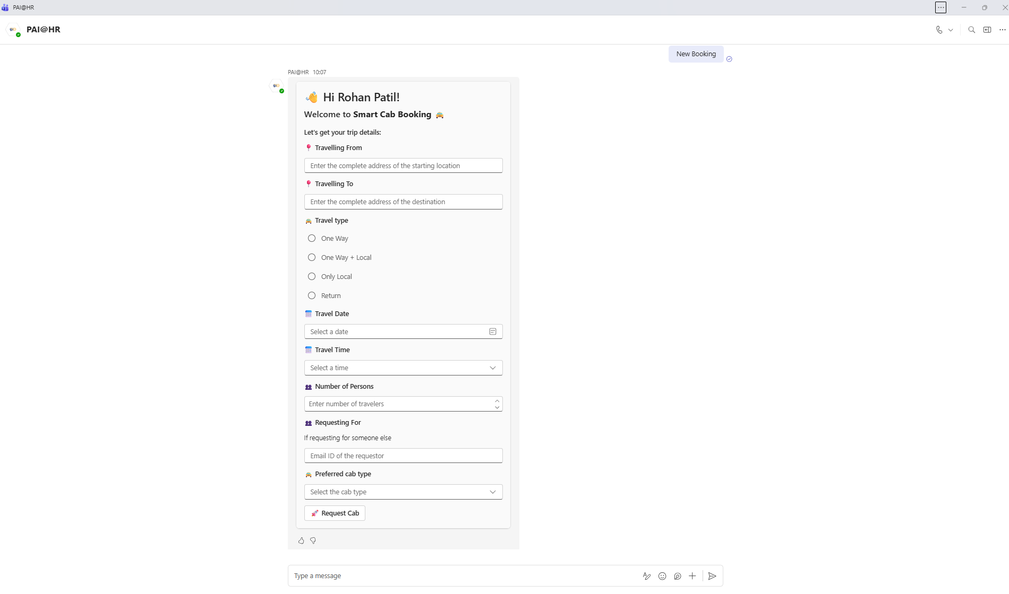

Step 4: Fill in the cab request form.
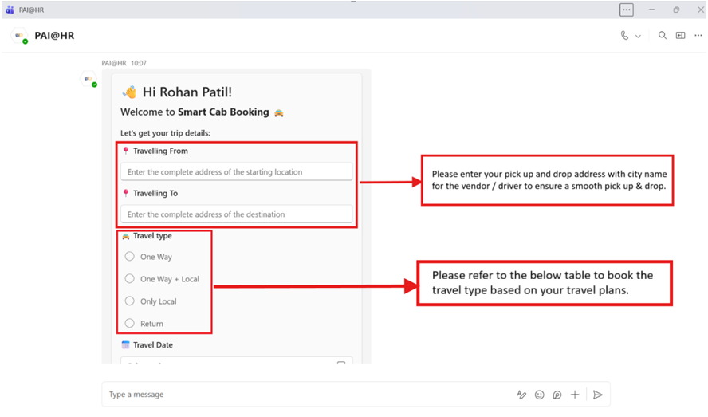
Travel Type Combinations:
Travel Type | Scenarios
One Way  (Up to 200 km / 6 hrs. travel time) | Please use this service for one-way transfers. This is to be booked ideally in the scenarios where one needs to travel intercity and typically stay back in that city and travel the next day or some other date. We have negotiated with our vendor to give us a special rate for this service and not charge us the outstation fare.  This service is only applicable to Mumbai – Pune or vice versa currently.
One Way + Local  (Up to 200 km / 6 hrs. travel time) for one way.  (8 hrs. / 80 km) for local city use within the city limits. | Please use this combination when you have any meetings or work in the city of origin or the drop location city. In these scenarios the vendor ensures the same cab is allotted to you for intercity transfers along with local use and the fare will be charged accordingly.  This is also applicable when there is multiple pickup or drop points which involves a reasonable deviation from your original route.  If the driver is kept waiting for longer than the requested timings, in such scenarios the vendor will charge us a local duty fare over and above the one-way fare.
Only Local  (8 hrs. / 80 km) for local city use within the city limits. | Please use this booking when you need cab for local commute within the city limits, ideally this service offers you cab at disposal for a period of minimum 8 hrs./ 80 km or at actuals.  We don’t recommend this cab service for only airport transfers as the vendor will charge us full day service cost. We recommend usage of app-based cabs wherever applicable.
Return  (Minimum 300 km per day or on actuals) whichever is on the higher side. | When the travel itinerary is for the same day return for intercity travel then this type of service is to be booked.  Any other locations apart from Mumbai – Pune travel falls under outstation travel, where this service needs to be booked.  If one needs to travel from one city to another city and end the service at the destination city, in that scenario too return / outstation fare will be charged by the vendor.
Step 4: Remaining cab booking form:
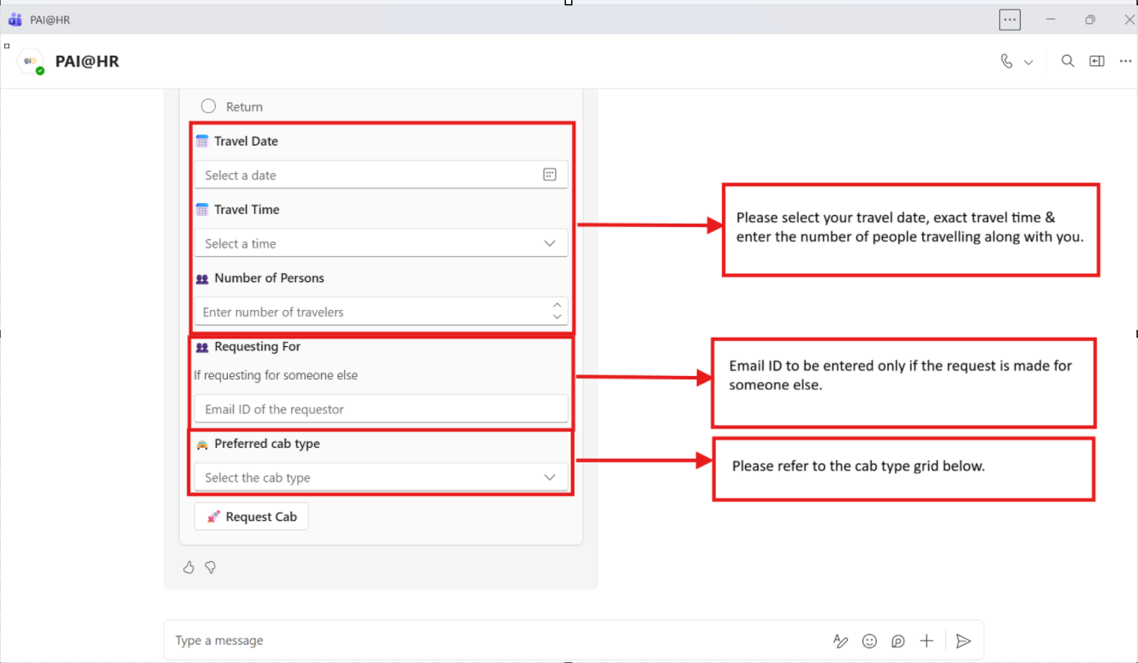
Cab Type Grid:
Cab Type | Cab Make / Model
Standard Sedan | Swift Dzire, Honda Aura, Honda Amaze or similar
Deluxe Sedan | Honda City, Kia Sonet, Toyota Hyryder, Maruti Ertiga or similar
Innova Crysta | Innova Crysta or similar

Step 5: Once all the above details are filled in the form correctly, then please proceed by clicking the “Request Cab” button.
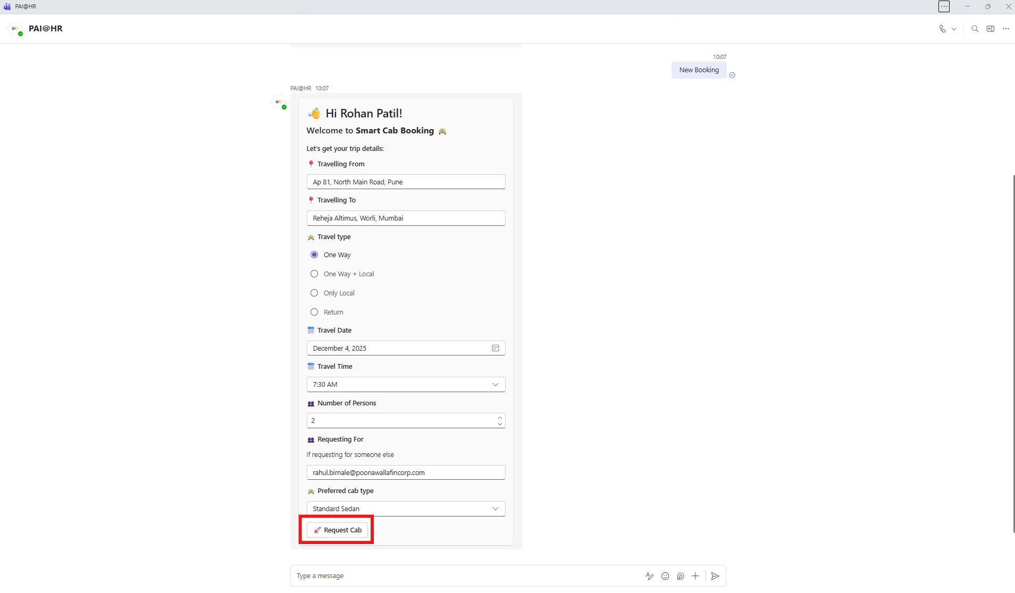

Step 6: The bot will pop up the below once you click the “Request cab” button.
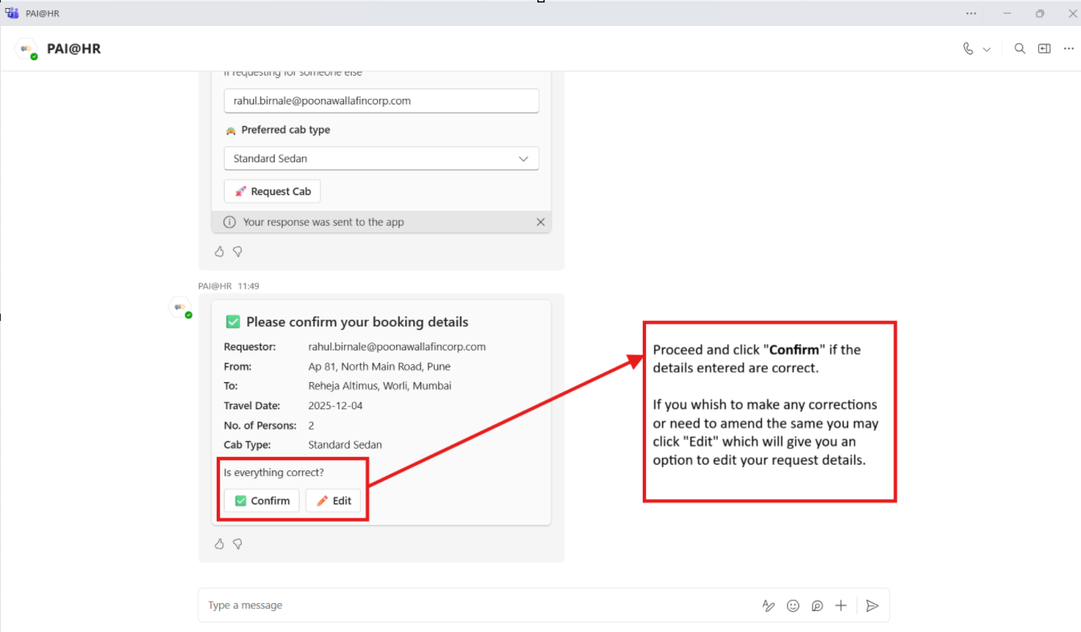
Step 7: Once you Confirm the above details, the below request details will follow. You need to click the “Submit” button once all the fields are filled.
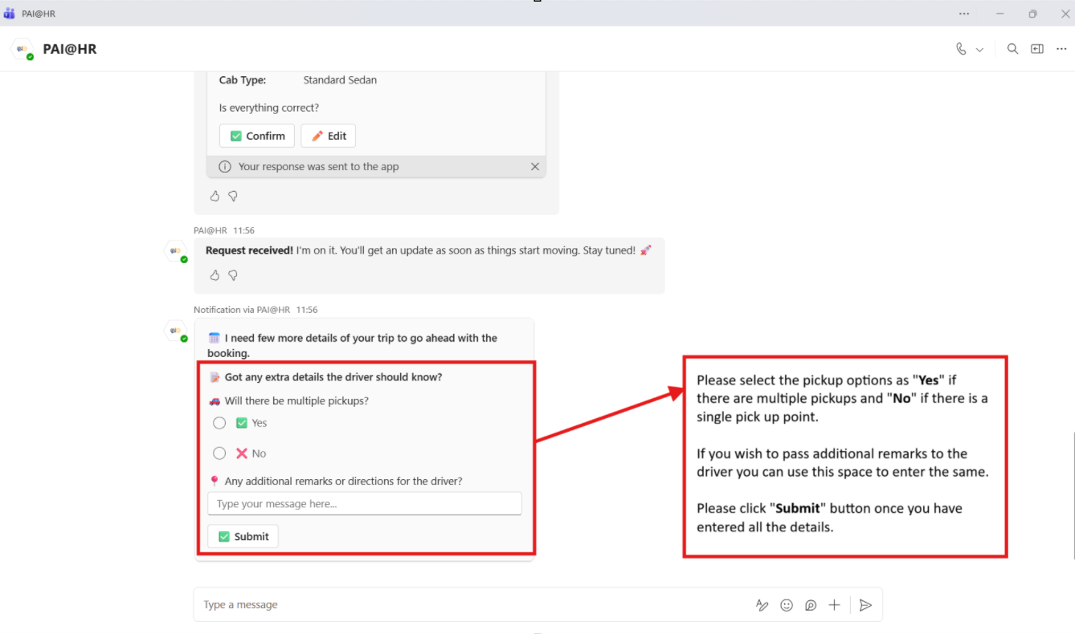
A “Trip ID” will be generated once the form the filled and submitted.
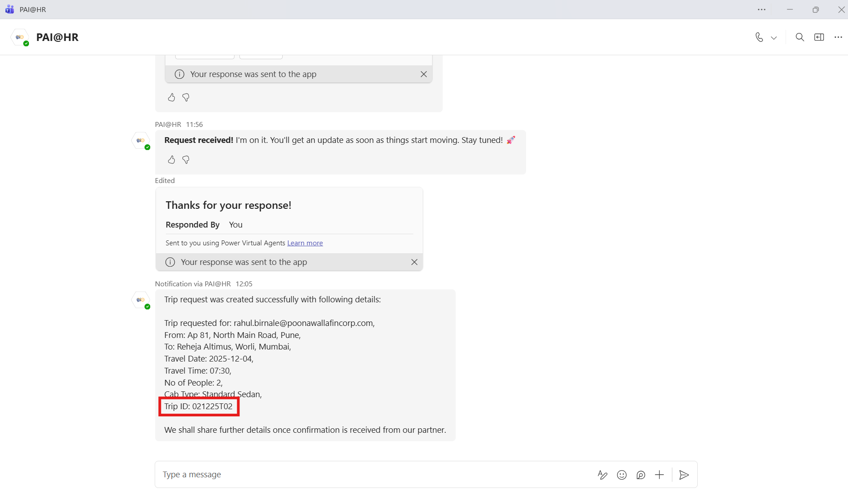
Once the vendor confirms the booking, the user will be communicated with the below booking details, soon after the request is made.
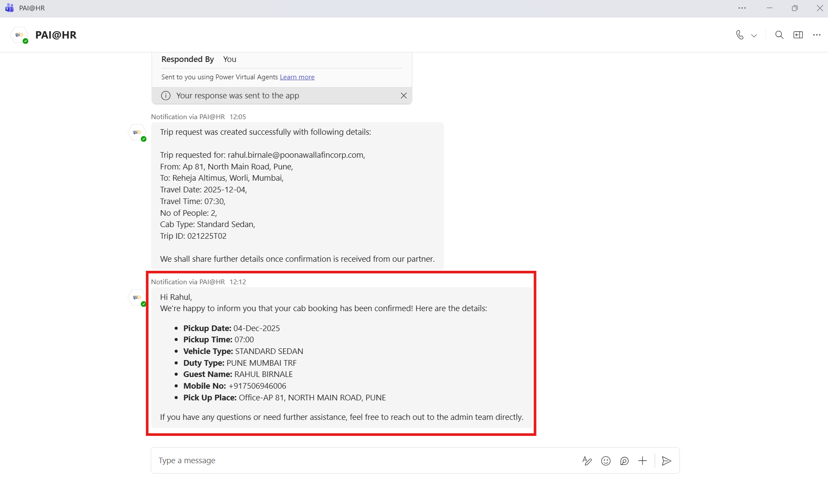
The cab & chauffer details are sent 4 hrs. prior to the travel time, if the duty falls early in the morning, then the details will be sent a day prior to the earlier night.
